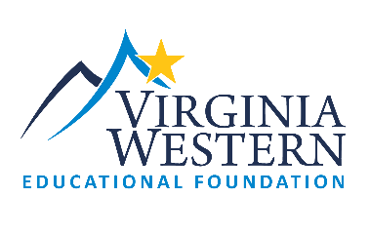
2023-2024
Virginia Western Educational Foundation
Innovation Grant Letter of Intent (LOI)
This LOI form is designed to provide initial feedback regarding Innovation ideas.
The LOI must be submitted in order to complete a full application*.
LOI Deadline: February 10, 2023

Please reply to the following areas to assist the Educational Foundation in understanding your Innovation idea.

Project goal(s): What are the goals you wish to achieve with your bright idea? What is the purpose of your request? (250 word maximum)

Project Outcomes: How will you measure success? (250 word maximum)
Budget: Please explain how you plan to use Innovation Funds? (please check anticipated budget categories below) Requests are limited to a maximum of $10,000. (250 word maximum)
Budget Categories:
Release Time (requires collaboration with HR) Certifications/Training Conference Attendance

Marketing (limited to 30% of grant total) Software/Equipment (requires IET collaboration)

Materials/Supplies/Other (please explain)

Please describe any anticipated budget needs noted as “Other”:

*Please note that full applications will require budget and signatures/approvals of immediate supervisor/department head/VP.

