What do we mean by Professional Readiness?
Virginia Western describes Professional Readiness as the ability to work well with others and display situationally and culturally appropriate demeanor and behavior.

A student that demonstrates professional Readiness will exhibit the following characteristics:
- strong management skills
- consistent attendance
- strong interpersonal skills
- positive workplace demeanor

How do we assess Professional Readiness?
Professional Readiness was assessed by 1 direct method of assessment and 2 indirect methods of assessment.

Direct Assessment Method
Professional Readiness was assessed by faculty using a rubric on selected artifacts; this rubric can be found in Appendix A. The threshold of acceptability was that 75% of students would earn an average rating of 2 and the target was an average rating of a 3.

Population for Direct Assessment Method
190 artifacts were assessed for 185 unique students for the Professional Readiness General Education Assessment. This represents 4.3% of the target population, program placed students (n=4272). The table below provides the respondent populations gender, race/ethnicity, degree type, and course modality.

Table 1 Respondent Population Demographics
Category | n | Percentage
Gender
Female | 117 | 63.24%
Male | 67 | 36.22%
Not specified | * | 0.54%
Race/ Ethnicity
Asian | 10 | 5.41%
Black | 18 | 9.73%
Hispanic | 16 | 8.65%
Not Specified | * | 2.16%
Two or More | 9 | 4.86%
White | 128 | 69.19%
Degree Type
AA | * | 1.62%
AAS | 38 | 20.54%
AS | 126 | 68.11%
CERT | 6 | 3.24%
CSC | 12 | 6.49%
Modality**
Face-to-Face | 123 | 64.74%
Hybrid | 16 | 8.42%
Online Asynchronous | 31 | 16.32%
Online Synchronous | 20 | 10.53%
Notes: * n is less than 5; ** students in multiple modalities

Indirect Assessment Method 1

To assess professional readiness for graduates, a graduation survey was conducted which asked graduates to rate their satisfaction with the professional readiness education they received while at Virginia Western; this survey question can be found in Appendix B. The threshold of acceptability was that 85% of respondents would rate their satisfaction with their professional readiness education as a 3 or better. The target for this method was that 75% of respondents will rate their satisfaction with their professional readiness education as a 4 or better.

Population
The sample population was 816 with 157 graduates responding. This is a response rate of 19.2%.

Table 2 Respondent Population Demographics
Category | n | Percentage
Gender
Female | 113 | 71.97%
Male | 43 | 27.39%
Not specified | * | 0.64%
Race/ Ethnicity
Asian | 7 | 4.46%
Black | 19 | 12.10%
Hispanic | 6 | 3.82%
Not Specified | * | 1.27%
Two or More | * | 2.55%
White | 119 | 75.80%
Degree Type
AA | 7 | 4.46%
AAS | 54 | 34.39%
AS | 61 | 38.85%
CERT | 8 | 5.10%
CSC | 27 | 17.20%
Notes: * n is less than 5

Indirect Assessment Method 2

To assess professional readiness with the alumni population, Virginia Western conducted an alumni survey which asked alumni to rate their satisfaction with the professional readiness education they received while at Virginia Western; this survey question can be found in Appendix B. The threshold of acceptability was that 85% of respondents would rate their satisfaction with their professional readiness education as a 3 or better. The target for this method was that 75% of respondents will rate their satisfaction with their professional readiness education as a 4 or better.

Population:
The 2442 individuals who either graduated during the 2020-2021 academic year or who attended during the 2020-2021 academic year and did not return for the 2021-2022 academic year were sent the survey. There was a response rate of 5.4% with 133 individuals responding to the survey.

Table 3 Respondent Population Demographics
Category | n | Percentage
Gender
Female | 83 | 62.41%
Male | 48 | 36.09%
Not specified | * | 1.50%
Race/ Ethnicity
Asian | * | 3.01%
Black | 15 | 11.28%
Hispanic | 8 | 6.02%
Not Specified | * | 2.26%
Two or More | * | 1.50%
White | 101 | 75.94%
Degree Type
AA | * | 3.01%
AAS | 35 | 26.32%
AS | 34 | 25.56%
CERT | 5 | 3.76%
CSC | 55 | 41.35%
Graduation Status
Did Not Graduate | 39 | 29.32%
Graduated | 94 | 70.68%
Notes: * n is less than 5

What were our results?

Direct Assessment:
Method 1: Artifacts-based Assessments

Overall
190 artifacts were assessed across 185 students. Some artifacts assessed multiple of the professional readiness learning objectives. As depicted in Table 1 below, 92.1% of the artifacts met the threshold score of 2.00 for professional readiness; this exceeds the 75% threshold of acceptability. Additionally, with an average artifact score of 3.19, the target artifact score of 3.00 was achieved.

Table 1. Professional Readiness by Individual Student Learning Outcomes
 | Total number of artifacts assessed (N)* | Average Score | Number of students that met threshold (n) | Percent of students that met threshold (%)
Professional Readiness | 1096 | 3.19 | 1009 | 92.1%
Attendance/Accountability | 172 | 3.35 | 156 | 90.7%
Communication Skills | 189 | 3.15 | 178 | 94.2%
Participation/Teamwork | 173 | 3.17 | 161 | 93.1%
Quality of Work/Work Ethic | 188 | 3.10 | 168 | 89.4%
Time Management | 188 | 3.13 | 170 | 90.4%
Workplace Demeanor | 186 | 3.32 | 176 | 94.6%
* Artifact/student counted for each learning outcome that it assesses/it is assessed for.

Modality
Professional Readiness was assessed across four modalities – face-to-face, hybrid, online asynchronous, and online synchronous sections. As depicted in Table 2 below, all modalities met the 75% threshold of acceptability for percentage of students that met the threshold score of 2.00 – 91.1% of students in face-to-face sections met the threshold (N=123), 81.3% of students enrolled in hybrid sections met the threshold (N=16), 96.8% of students enrolled in online asynchronous sections met the threshold (N=31), and 100.0% of students in online synchronous sections met the threshold (N=20).

As shown in Table 2, the average score met the target score of 3.00 in face-to-face, online asynchronous, and online synchronous modalities (3.20, 3.07, and 3.58, respectively). Students enrolled in hybrid sections met the threshold score of acceptability (2.00) with an average score of 2.85.

Table 2. Professional Readiness by Modality
 | Total number of artifacts assessed (N) | Average Score | Number that met threshold (n) | Percent that met threshold (%)
Overall | 190 | 3.19 | 175 | 92.1%
Face-to-Face | 123 | 3.20 | 112 | 91.1%
Hybrid | 16 | 2.85 | 13 | 81.3%
Online – Asynchronous | 31 | 3.07 | 30 | 96.8%
Online - Synchronous | 20 | 3.58 | 20 | 100.0%

Gender
As depicted in Table 3 below, all genders met the 75% threshold of acceptability for percentage of students who met the threshold score of 2.00 – 91.7% of female students met the threshold (N=121) 92.6% of male students met the threshold (N=68), and 100.0% students with unspecified gender met the threshold (N<10). Table 3 also establishes the average score met the target score of 3.00 for females and males (3.24 and 3.11, respectively). Students with an unspecified gender met the threshold score of acceptability (2.00) with an average score of 2.17.

Table 3. Professional Readiness by Gender
 | Total number of artifacts assessed (N) | Average Score | Number that met threshold (n) | Percent that met threshold (%)
Overall | 190 | 3.19 | 175 | 92.1%
Female | 121 | 3.24 | 111 | 91.7%
Male | 68 | 3.11 | 63 | 92.6%
Not Specified | * | 2.17 | * | 100.0%
* Sample size is less than ten students

Race/Ethnicity
As depicted in Table 4 below, all races met the 75% threshold of acceptability for percentage of students who met the threshold score of 2.00 – 100.0% of Asian students met the threshold (N=10), 78.9% of Black students met the threshold (N=19), 88.2% of Hispanic students met the threshold (N=17), 75.0% of students with an unspecified race/ethnicity met the threshold (N<10), 100.0% of students who identify as two or more races met the threshold (N=10), and 93.8% of White students met the threshold (N=130).

As shown in Table 4, the average score met the target score of 3.00 for Asian, Hispanic, Two or More, and White students (3.40, 3.11, 3.62, and 3.24, respectively). Black and Unspecified race students met the threshold score of acceptability (2.00) with an average score of 2.74 and 2.29, respectively.

Table 4. Professional Readiness by Race/Ethnicity
 | Total number of artifacts assessed (N) | Average Score | Number of students that met threshold (n) | Percent of students that met threshold (%)
Overall | 190 | 3.19 | 175 | 92.1%
Asian | 10 | 3.40 | 10 | 100.0%
Black | 19 | 2.74 | 15 | 78.9%
Hispanic | 17 | 3.11 | 15 | 88.2%
Not Specified | * | 2.29 | * | 75.0%
Two or More | 10 | 3.62 | 10 | 100.0%
White | 130 | 3.24 | 122 | 93.8%
* Sample size is less than ten students

Award/Degree Type
As depicted in Table 5 below, all award types met the 75% threshold of acceptability for percentage of students who met the threshold score of 2.00 – 100.0% of students seeking an Associate of Arts (AA) degree met the threshold (N<10), 90.1% of students seeking an Associate of Science (AS) degree met the threshold (N=131), 97.4% of students seeking an Associate of Applied Science (AAS) degree met the threshold (N=38), 100.0% of students seeking an Certification (CERT) met the threshold (N<10), and 91.7% of students seeking a Career Studies Certificate (CSC) met the threshold (N=12).

As shown in Table 5, the average score met the target score of 3.00 for students seeking AA, AS, AAS, CERT, and CSC awards (3.51, 3.05, 3.70, 3.17, and 3.07, respectively).

Table 5. Professional Readiness by Award/Degree
 | Total number of artifacts assessed (N) | Average Score | Number that met threshold (n) | Percent that met threshold (%)
Overall | 190 | 3.19 | 175 | 92.1%
Associate of Arts (AA) | * | 3.51 | * | 100.0%
Associate of Science (AS) | 131 | 3.05 | 118 | 90.1%
Associate of Applied Science (AAS) | 38 | 3.70 | 37 | 97.4%
Certification (CERT) | * | 3.17 | * | 100.0%
Career Studies Certificate (CSC) | 12 | 3.07 | 11 | 91.7%
* Sample size is less than ten students

Indirect Assessment:
Method 1: Graduation Survey

Overall
As depicted in Table 6 below, 100.0% of graduates answered “Neutral,” “Satisfied,” or “Very Satisfied” regarding their satisfaction with their professional readiness education – this met the threshold of acceptability of 85%. Additionally, with an average satisfaction score of 4.43, the target satisfaction score of 4.00 was achieved.

Table 6. Overall Professional Readiness
 | Total number of artifacts assessed (N) | Average Score | Number that met threshold (n) | Percent that met threshold (%)
Overall | 157 | 4.43 | 157 | 100.0%

Gender
As depicted in Table 7 below, all genders met the 85% threshold of acceptability for percentage of graduates who met the threshold satisfaction score of 3.00 – 100.0% of scores from female graduates met the threshold (N=113), 100.0% of scores obtained from male graduates met the threshold (N=43), and 100.0% of the scores from graduates with an unspecified gender met the threshold (N < 10). As shown in Table 7, the average satisfaction score met the target score of 4.00 for females, males, and unspecified genders (4.43, 4.42, and 5.00, respectively).

Table 7. Professional Readiness by Gender
 | Total number of artifacts assessed (N) | Average Score | Number that met threshold (n) | Percent that met threshold (%)
Overall | 157 | 4.43 | 157 | 100.0%
Female | 113 | 4.43 | 113 | 100.0%
Male | 43 | 4.42 | 43 | 100.0%
Not Specified | * | 5.00 | * | 100.0%
* Sample size is less than ten graduates

Race/Ethnicity
As depicted in Table 8 below, all races had 100% of graduates who met the threshold satisfaction score of 3.00; this meets the 85% threshold of acceptability. As shown in Table 8, the average satisfaction score met the target score of 4.00 for Asian, Black, Unspecified, Two or More races and White graduates (4.71, 4.21, 4.00, 4.00 and 4.50, respectively). Hispanic graduates had satisfaction scores met the threshold score of acceptability (3.00) with an average score of 3.83.

Table 8. Professional Readiness by Race/Ethnicity
 | Total number of artifacts assessed (N) | Average Score | Number that met threshold (n) | Percent that met threshold (%)
Overall | 157 | 4.43 | 157 | 100.0%
Asian | * | 4.71 | * | 100.0%
Black | 19 | 4.21 | 19 | 100.0%
Hispanic | * | 3.83 | * | 100.0%
Not Specified | * | 4.00 | * | 100.0%
Two or More | * | 4.00 | * | 100.0%
White | 119 | 4.50 | 119 | 100.0%
* Sample size is less than ten graduates

Award/Degree

As depicted in Table 9 below, all award types had 100% of graduates who met the threshold satisfaction score of 3.00; this meets the 85% threshold of acceptability. As shown in Table 9, the average satisfaction score met the target score of 4.00 for graduates earning an Associate of Arts (AA) degree, an Associate of Science (AS) degree, an Associate of Applied Science (AAS) degree, or a Career Studies Certificate (CSC) (4.43, 4.41, 4.50, and 4.56, respectively). Graduates earning a Certificate (CERT) had an average satisfaction score of 3.75, which meets the threshold score of acceptability (3.00).

Table 9. Professional Readiness by Award/Degree Type
 | Total number of artifacts assessed (N) | Average Score | Number that met threshold (n) | Percent that met threshold (%)
Overall | 157 | 4.43 | 157 | 100.0%
Associate of Arts (AA) | * | 4.43 | * | 100.0%
Associate of Science (AS) | 61 | 4.41 | 61 | 100.0%
Associate of Applied Science (AAS) | 54 | 4.50 | 54 | 100.0%
Certification (CERT) | * | 3.75 | * | 100.0%
Career Studies Certificate (CSC) | 27 | 4.56 | 27 | 100.0%
* Sample size is less than ten graduates

Method 3: Alumni Survey

Overall
As depicted in Table 10 below, 97.0% of the alumni answered “Neutral,” “Satisfied,” or “Very Satisfied” regarding their satisfaction with their professional readiness education – this met the threshold of acceptability of 85%. Additionally, with an average satisfaction score of 4.25, the target satisfaction score of 4.00 was achieved.

Table 10. Overall Professional Readiness
 | Total number of artifacts assessed (N) | Average Score | Number that met threshold (n) | Percent that met threshold (%)
Overall | 133 | 4.25 | 129 | 97.0%

Gender
As depicted in Table 11 below, females and males met the 85% threshold of acceptability for percentage of alumni who met the threshold satisfaction score of 3.00 – 96.4% of scores from female alumna met the threshold (N=83) and 100.0% of scores obtained from male alumnus met the threshold (N=48). With a sample size less than ten, only 50.0% of the scores from alumni with an unspecified gender met the threshold satisfaction score; this percentage does not meet the threshold of acceptability (85%).
As shown in Table 11, the average satisfaction score met the target score of 4.00 for females and males (4.35 and 4.13, respectively). The satisfaction score of alumni with an unspecified gender met the threshold score of acceptability (3.00) with an average score of 3.00.

Table 11. Professional Readiness by Gender
 | Total number of artifacts assessed (N) | Average Score | Number that met threshold (n) | Percent that met threshold (%)
Overall | 133 | 4.25 | 129 | 97.0%
Female | 83 | 4.35 | 80 | 96.4%
Male | 48 | 4.13 | 48 | 100.0%
Not Specified | * | 3.00 | * | 50.0%
* Sample size is less than ten alumni

Race/Ethnicity
As depicted in Table 12 below, all races met the 85% threshold of acceptability for percentage of alumni who met the threshold satisfaction score of 3.00 – 100.0% of scores from Asian alumni met the threshold (N < 10), 93.3% of scores obtained from Black alumni met the threshold (N=15), 100.0% of the scores from Hispanic alumni met the threshold (N < 10), 100.0% of the scores from alumni who did not specify their gender met the threshold (N < 10), 100.0% of the scores from alumni who identify as two or more races met the threshold (N < 10), and 97.0% of the scores from White alumni met the threshold (N=101).

As shown in Table 12, the average satisfaction score met the target score of 4.00 for Asian, Black, Hispanic, Two or More, and White alumni (4.50, 4.33, 4.25, 4.50, and 4.24, respectively). Alumni who did not specify race had a satisfaction score of 3.67; this meets the threshold score of acceptability (3.00).

Table 12. Professional Readiness by Race/Ethnicity
 | Total number of artifacts assessed (N) | Average Score | Number that met threshold (n) | Percent that met threshold (%)
Overall | 133 | 4.25 | 129 | 97.0%
Asian | * | 4.50 | * | 100.0%
Black | 15 | 4.33 | 14 | 93.3%
Hispanic | * | 4.25 | * | 100.0%
Not Specified | * | 3.67 | * | 100.0%
Two or More | * | 4.50 | * | 100.0%
White | 101 | 4.24 | 98 | 97.0%
* Sample size is less than ten alumni

Award/Degree

As depicted in Table 13 below, all awards/degrees met the 85% threshold of acceptability for percentage of alumni who met the threshold satisfaction score of 3.00 – 100.0% of scores from alumni seeking an Associate of Arts (AA) degree met the threshold (N < 10), 94.1% of scores obtained alumni seeking an Associate of Science (AS) degree met the threshold (N=34), 97.1% of the scores from alumni seeking an Associate of Applied Science (AAS) degree met the threshold (N=35), 100.0% of the scores from alumni seeking a Certification (CERT) met the threshold (N < 10), and 98.2% of the scores from alumni seeking to earn a Career Studies Certificate (CSC) met the threshold (N=55).

As shown in Table 13, the average satisfaction score met the target score of 4.00 for alumni seeking an AS degree, AAS degree, CERT, or CSC (4.15, 4.37, 4.20, and 4.27, respectively). Alumni seeking an AA degree had satisfaction scores met the threshold score of acceptability (3.00) with an average score of 3.75.

Table 13. Professional Readiness by Award/Degree Type
 | Total number of artifacts assessed (N) | Average Score | Number that met threshold (n) | Percent that met threshold (%)
Overall | 133 | 4.25 | 129 | 97.0%
Associate of Arts (AA) | * | 3.75 | * | 100.0%
Associate of Science (AS) | 34 | 4.15 | 32 | 94.1%
Associate of Applied Science (AAS) | 35 | 4.37 | 34 | 97.1%
Certification (CERT) | * | 4.20 | * | 100.0%
Career Studies Certificate (CSC) | 55 | 4.27 | 54 | 98.2%
* Sample size is less than ten alumni

Graduation Status

As depicted in Table 14 below, both graduation statuses met the 85% threshold of acceptability for percentage of students who met the threshold satisfaction score of 3.00 – 94.9% of scores from non-graduate alumnus met the threshold (N=39) and 97.9% of scores from students who graduated met the threshold (N=94). As shown in Table 10, the average satisfaction score met the target score of 4.00 for alumni who graduated (4.38). Alumni who did not graduate had satisfaction scores met the threshold score of acceptability (3.92).

Table 14. Professional Readiness by Graduation Status
 | Total number of artifacts assessed (N) | Average Score | Number that met threshold (n) | Percent that met threshold (%)
Overall | 133 | 4.25 | 129 | 97.0%
Non-Graduates | 39 | 3.92 | 37 | 94.9%
Graduates | 94 | 4.38 | 92 | 97.9%
* Sample size is less than ten alumni

Have results changed since the last time this competency was assessed?
Professional Readiness was evaluated for this first time in 2021-22. A comparative analysis will be made in the next cycle of assessments for this competency.

What changes are we making to improve student learning for Professional Readiness?

The governance Assessment Committee will be presented with and review the Professional Readiness results in the Fall 2022. Recommendations will be established by the committee and presented to the Faculty Senate for approval.

Summary

For the direct, artifact-based assessment, VWCC is meeting its threshold of acceptability of 75% of students earning a 2.00 or better. With an average score of 3.19, this also meets the target score. This direct assessment shows that VWCC students are proficient across all aspects of the professional readiness rubric.

For the two indirect assessments, VWCC graduates and alumni met all targets. According to the 2022 Graduation Survey, 100% of VWCC graduates rated their satisfaction with their professional readiness education as 3.00 or better, exceeding the threshold of acceptability of 85%. Similarly, in the 2022 Alumni Survey, 97% of VWCC alumni rated their satisfaction with their civic engagement education as 3.00 or better out of 5.00. This meets the threshold of acceptability of 85%. However, while the alumni survey shows that VWCC students are satisfied with their professional readiness education overall, students with unspecified gender do not meet the threshold of acceptability for the percentage of students whose average satisfaction score is 3.00 or better. It should be noted that this subset of alumni has a sample size less than five.

In conclusion, while examining overall assessment results, VWCC students are proficient in their professional development skills and meet all thresholds of acceptability. However, there is room for improvement among certain subpopulations. This report will be shared with the governance Assessment Committee for feedback and next steps.

Appendix A – Professional Readiness Rubric

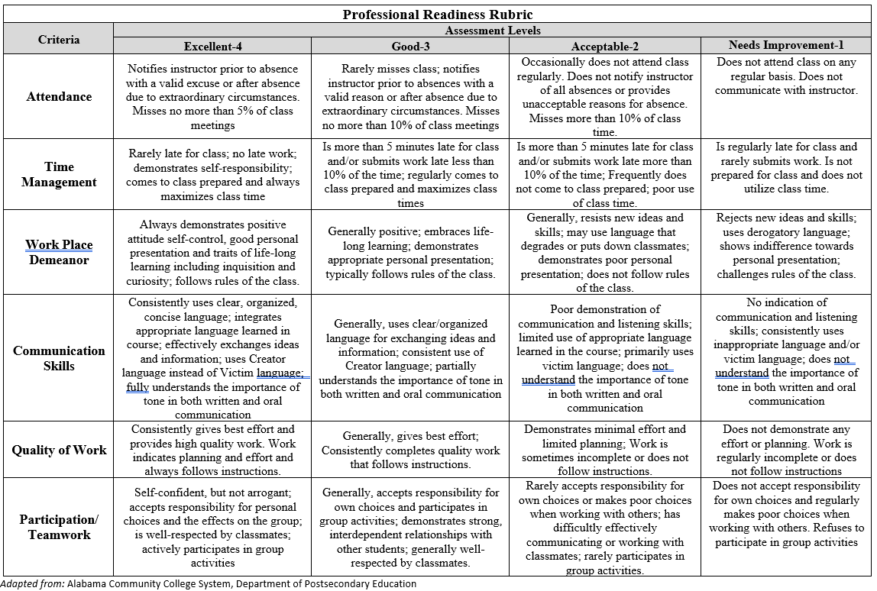

Appendix B – Graduation and Alumni Survey Examples

Image 1. Graduation Survey Civic Engagement Satisfaction Question
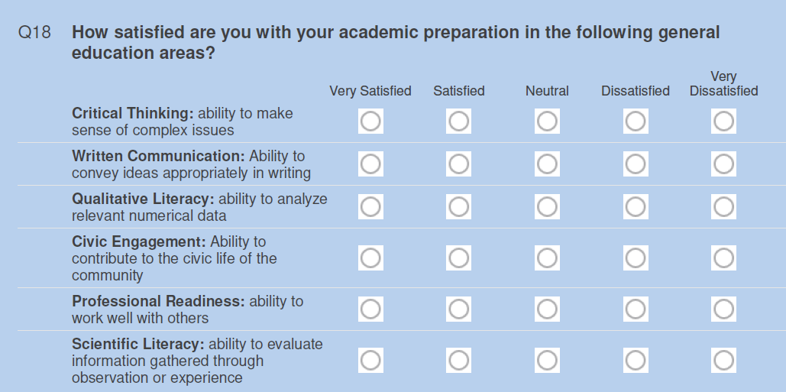

Image 2. Alumni Survey Civic Engagement Satisfaction Question
