What do we mean by Civic Engagement?
Civic Engagement is defined as the ability to contribute to the civic life and well-being of local, national, and global communities as both a social responsibility and a life-long learning process.

A civically engaged student will:
- analyze knowledge from and make connections to civic engagement
- participate in civic engagement activities and describe what was learned about him or herself
- demonstrate the ability to communicate in a civic context
- participate in civic action and reflection

How do we assess Civic Engagement?

Civic Engagement was assessed by 1 direct method of assessment and 3 indirect methods of assessment.

Direct Assessment Method
Civic engagement was assessed by faculty using a rubric on selected artifacts; this rubric can be found in Appendix A. The threshold of acceptability was that 75% of students would earn an average rating of 2 and the target was an average rating of a 3.

Population for Direct Assessment Method
89 artifacts were assessed for 86 unique students for the Civic Engagement General Education Assessment. This represents 2.0% of the target population, program placed students (n=4272). The table below provides the respondent populations gender, race/ethnicity, degree type, and course modality.

Table 1 Respondent Population Demographics
Category | n | Percentage
Gender
Female | 51 | 59.30%
Male | 34 | 39.53%
Not specified | * | 1.16%
Race/ Ethnicity
Asian | * | 2.33%
Black | 6 | 6.98%
Hispanic | 5 | 5.81%
Two or More | * | 2.33%
White | 71 | 82.56%
Degree Type
AA | * | 2.33%
AAS | 13 | 15.12%
AS | 69 | 80.23%
CERT | * | 1.16%
CSC | * | 1.16%
Modality**
Online Asynchronous | 65 | 73.03%
Hybrid | 24 | 26.97%
Notes: * n is less than 5; ** students in multiple modalities

Indirect Assessment Method 1

Virginia Western assessed students’ civic engagement through participation in the 2020 national elections through the National Study of Learning, Voting and Engagement (NSLVE). Virginia Western had a target of 60% of eligible students will register to vote and there was a threshold of acceptability of 50% of eligible students registered to vote.

Population: The target population for the voter registration method was 3,302 students. The respondent sample size was 2,721 which is 82.4% of the target population.

Indirect Assessment Method 2

To assess civic engagement for graduates, a graduation survey was conducted which asked graduates to rate their satisfaction with the civic engagement education they received while at Virginia Western; this survey question can be found in Appendix B. The threshold of acceptability was that 85% of respondents would rate their satisfaction with their civic engagement education as a 3 or better. The target for this method was that 75% of respondents will rate their satisfaction with their civic engagement education as a 4 or better.

Population
The sample population was 816 with 157 graduates responding. This is a response rate of 19.2%.

Table 2 Respondent Population Demographics
Category | n | Percentage
Gender
Female | 114 | 72.61%
Male | 42 | 26.75%
Not specified | * | 0.64%
Race/ Ethnicity
Asian | 7 | 4.46%
Black | 18 | 11.46%
Hispanic | 6 | 3.82%
Not Specified | * | 1.27%
Two or More | * | 2.55%
White | 120 | 76.43%
Degree Type
AA | 7 | 4.46%
AAS | 54 | 34.39%
AS | 61 | 38.85%
CERT | 8 | 5.10%
CSC | 27 | 17.20%
Notes: * n is less than 5

Indirect Assessment Method 3

To assess civic engagement with the alumni population, Virginia Western conducted an alumni survey which asked alumni to rate their satisfaction with the civic engagement education they received while at Virginia Western; this survey question can be found in Appendix B. The threshold of acceptability was that 85% of respondents would rate their satisfaction with their civic engagement education as a 3 or better. The target for this method was that 75% of respondents will rate their satisfaction with their civic engagement education as a 4 or better.

Population:
The 2442 individuals who either graduated during the 2020-2021 academic year or who attended during the 2020-2021 academic year and did not return for the 2021-2022 academic year were sent the survey. There was a response rate of 5.4% with 133 individuals responding to the survey.

Table 3 Respondent Population Demographics
Category | n | Percentage
Gender
Female | 83 | 62.41%
Male | 48 | 36.09%
Not specified | * | 1.50%
Race/ Ethnicity
Asian | * | 3.01%
Black | 15 | 11.28%
Hispanic | 8 | 6.02%
Not Specified | * | 2.26%
Two or More | * | 1.50%
White | 101 | 75.94%
Degree Type
AA | * | 3.01%
AAS | 35 | 26.32%
AS | 34 | 25.56%
CERT | 5 | 3.76%
CSC | 55 | 41.35%
Graduation Status
Did Not Graduate | 39 | 29.32%
Graduated | 94 | 70.68%
Notes: * n is less than 5

What were our results?

Direct Assessment:
Method 1: Artifacts-based Assessments

Overall
89 artifacts were assessed across 86 students. Some artifacts assessed multiple civic engagement learning objectives. As depicted in Table 1 below, 78.7% met the threshold score of 2.00 for Civic Engagement; this exceeds the 75% threshold of acceptability. Additionally, with an average artifact score of 3.06, the target artifact score of 3.00 was achieved.

Table 1. Civic Engagement by Individual Student Learning Outcomes
 | Total number of artifacts assessed (N)* | Average Score | Number of students that met threshold (n) | Percent of students that met threshold (%)
Civic Engagement | 318 | 3.06 | 248 | 78.7%
Analysis of Knowledge | 89 | 2.94 | 68 | 76.4%
Civic Action and Reflection | 70 | 3.19 | 60 | 85.7%
Civic Communication | 89 | 2.97 | 60 | 67.4%
Civic Identity and Commitment | 70 | 3.19 | 60 | 85.7%
* Artifact/student counted for each learning outcome that it assesses/it is assessed for.

Modality
Civic Engagement was assessed in two modalities – hybrid and online asynchronous sections. As depicted in Table 2 below, both modalities met the 75% threshold of acceptability for percentage of students who met the threshold score of 2.00 – 79.4% of artifacts obtained in online asynchronous sections met the threshold (N=65) and 75.0% of students enrolled in hybrid sections met the threshold (N=24). As shown in Table 2, the average score met the target score of 3.00 across both modalities – 3.06 (online asynchronous) and 3.08 (hybrid).

Table 2. Civic Engagement by Modality
 | Total number of artifacts assessed (N) | Average Score | Number that met threshold (n) | Percent that met threshold (%)
Overall | 89 | 3.06 | 70 | 78.7%
Hybrid | 24 | 3.08 | 18 | 75.0%
Online - Asynchronous | 65 | 3.06 | 52 | 80.0%

Gender
As depicted in Table 3 below, all genders met the 75% threshold of acceptability for percentage of students who met the threshold score of 2.00 –77.4% of artifacts from female students met the threshold (N=41), 80.0% of male students met the threshold (N=35), and 100.0% of students with an unspecified gender met the threshold (N < 10). Table 3 also establishes the average score met the target score of 3.00 for males and unspecified genders (3.06 and 4.0, respectively). Artifacts from female students met the threshold score of acceptability (2.00) with an average score of 2.94 but did not meet the goal of 3.00.

Table 3. Civic Engagement by Gender
 | Total number of artifacts assessed (N) | Average Score | Number that met threshold (n) | Percent that met threshold (%)
Overall | 89 | 3.06 | 70 | 78.7%
Female | 53 | 2.94 | 41 | 77.4%
Male | 35 | 3.06 | 28 | 80.0%
Not Specified | * | 4.00 | * | 100.0%
* Sample size is less than ten students

Race/Ethnicity
As depicted in Table 4 below, all races met the 75% threshold of acceptability for percentage of students who met the threshold score of 2.00 – 100.0% of Asian students met the threshold (N<10), 83.3% of Black students met the threshold (N<10), 80.0% of artifacts obtained from Hispanic students met the threshold (N<10), and 78.1% of the artifacts from White students met the threshold (N=73). As shown in Table 4, the average score for artifacts met the target score of 3.00 for Asian, Black, and Hispanic students (4.00, 3.33, and 3.0, respectively). Students who identified as two or more races and White students met the threshold score of acceptability (2.00) with an average score of 2.50 and 2.94, respectively.

Table 4. Civic Engagement by Race/Ethnicity
 | Total number of artifacts assessed (N) | Average Score | Number that met threshold (n) | Percent that met threshold (%)
Overall | 89 | 3.06 | 70 | 78.7%
Asian | * | 4.00 | * | 100.0%
Black | * | 3.33 | * | 83.3%
Hispanic | * | 3.00 | * | 80.0%
Two or More | * | 2.50 | * | 50.0%
White | 73 | 2.94 | 57 | 78.1%
* Sample size is less than ten students

Award/Degree Type
As depicted in Table 5 below, all award types with a sample size greater than or equal to ten met the 75% threshold of acceptability for percentage of students who met the threshold score of 2.00 – 78.9% of students seeking an Associate of Science (AS) degree met the threshold (N=71) and 78.6% of students seeking an Associate of Applied Science (AAS) degree met the threshold (N=14). There were less than ten students, respectively, seeking an Associate of Arts (AA), a Certification, or a Career Studies Certificate (CSC). AA and Certification students met the 75% threshold of acceptability for percentage of students who met the threshold score of 2.0 (100.0% for both groups), while CSC students did not meet the threshold percentage of 75% (0.0%).

As shown in Table 5, the average score for artifacts met the target score of 3.00 for students seeking AA, AS, and Certification awards (4.00, 3.01, and 3.00, respectively). Artifacts from students seeking an AAS and CSC did not meet the target score of 3.00. AAS students met the threshold score of acceptability (2.00) with an average score of 2.93, CSC students did not meet the threshold of acceptability; however, it should be noted that this group of students had a very low n size.

Table 5. Civic Engagement by Award/Degree
 | Total number of artifacts assessed (N) | Average Score | Number that met threshold (n) | Percent that met threshold (%)
Overall | 89 | 3.06 | 70 | 78.7%
Associate of Arts (AA) | * | 4.00 | * | 100.0%
Associate of Science (AS) | 71 | 3.01 | 56 | 78.9%
Associate of Applied Science (AAS) | 14 | 2.93 | 11 | 78.6%
Certification (CERT) | * | 3.00 | * | 100.0%
Career Studies Certificate (CSC) | * | 1.00 | * | 0.0%
* Sample size is less than ten students

Indirect Assessment:
Method 1: Voting Rates
The following results are based on NSLVE’s “Voting Rate,” which is the percentage of eligible students who voted on Election Day. According to the most current NSLVE report, 62.2% of Virginia Western’s eligible students voted in the national election in 2016, and 68.2% voted in the 2020 national elections. This represents an increase of 6% in voting rates, despite concerns regarding COVID-19 impacting voter turnout. In addition, Virginia Western’s 2020 voting rage was 2.2% higher than the voting rate average of all institutions (66%) partnering with NSLVE. Virginia Western successfully met its standard of success to maintain 60% voting rate in the 2020 national elections.

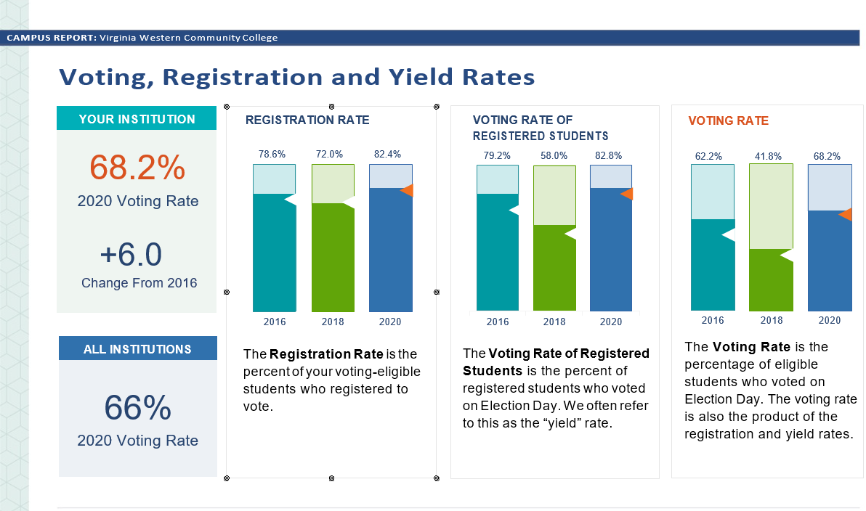

Method 2: Graduation Survey

Overall
As depicted in Table 6 below, 100.0% of graduates answered “Neutral,” “Satisfied,” or “Very Satisfied” regarding their satisfaction with their civic engagement education – this met the threshold of acceptability of 85%. Additionally, with an average satisfaction score of 4.25, the target satisfaction score of 4.00 was achieved.

Table 6. Overall Civic Engagement
 | Total number of respondents (N) | Average Score | Number that met threshold (n) | Percent that met threshold (%)
Overall | 157 | 4.25 | 157 | 100.0%

Gender
As depicted in Table 7 below, all genders met the 85% threshold of acceptability for percentage of alumni who met the threshold satisfaction score of 3.00 – 100.0% of scores from female graduates met the threshold (N=114), 100.0% of scores obtained from male graduates met the threshold (N=42), and 100.0% of the scores from graduates with an unspecified gender met the threshold (N < 10). As shown in Table 7, the average satisfaction score met the target score of 4.00 for females, males, and unspecified genders (4.22, 4.31, and 5.00, respectively).

Table 7. Civic Engagement by Gender
 | Total number of respondents (N) | Average Score | Number that met threshold (n) | Percent that met threshold (%)
Overall | 157 | 4.25 | 157 | 100.0%
Female | 114 | 4.22 | 114 | 100.0%
Male | 42 | 4.31 | 42 | 100.0%
Not Specified | * | 5.00 | * | 100.0%
* Sample size is less than ten graduates

Race/Ethnicity
As depicted in Table 8 below, all races had 100% of graduates who met the threshold satisfaction score of 3.00; this meets the 85% threshold of acceptability. As shown in Table 8, the average satisfaction score met the target score of 4.00 for Asian, Black, Unspecified, and White graduates (4.43, 4.06, 4.00, and 4.32, respectively). Hispanic graduates and graduates who identified as two or more races had satisfaction scores met the threshold score of acceptability (3.00) with an average score of 3.83 and 3.50, respectively.

Table 8. Civic Engagement by Race/Ethnicity
 | Total number of respondents (N) | Average Score | Number that met threshold (n) | Percent that met threshold (%)
Overall | 157 | 4.25 | 157 | 100.0%
Asian | * | 4.43 | * | 100.0%
Black | 18 | 4.06 | 18 | 100.0%
Hispanic | * | 3.83 | * | 100.0%
Not Specified | * | 4.00 | * | 100.0%
Two or More | * | 3.50 | * | 100.0%
White | 120 | 4.32 | 120 | 100.0%
* Sample size is less than ten graduates

Award/Degree

As depicted in Table 9 below, all award types had 100% of graduates who met the threshold satisfaction score of 3.00; this meets the 85% threshold of acceptability. As shown in Table 9, the average satisfaction score met the target score of 4.00 for graduates earning an Associate of Arts (AA) degree, an Associate of Science (AS) degree, an Associate of Applied Science (AAS) degree, or a Career Studies Certificate (CSC) (4.29, 4.20, 4.35, and 4.30, respectively). Graduates earning a Certificate (CERT) had an average satisfaction score of 3.75, which meets the threshold score of acceptability (3.00).

Table 9. Civic Engagement by Award/Degree Type
 | Total number of respondents (N) | Average Score | Number that met threshold (n) | Percent that met threshold (%)
Overall | 157 | 4.25 | 157 | 100.0%
Associate of Arts (AA) | * | 4.29 | * | 100.0%
Associate of Science (AS) | 61 | 4.20 | 61 | 100.0%
Associate of Applied Science (AAS) | 54 | 4.35 | 54 | 100.0%
Certification (CERT) | * | 3.75 | * | 100.0%
Career Studies Certificate (CSC) | 27 | 4.30 | 27 | 100.0%
* Sample size is less than ten graduates

Method 3: Alumni Survey

Overall
As depicted in Table 10 below, 97.0% of the alumni answered “Neutral,” “Satisfied,” or “Very Satisfied” regarding their satisfaction with their civic engagement education – this met the threshold of acceptability of 85%. Additionally, with an average satisfaction score of 4.08, the target satisfaction score of 4.00 was achieved.

Table 10. Overall Civic Engagement
 | Total number of respondents (N) | Average Score | Number that met threshold (n) | Percent that met threshold (%)
Overall | 133 | 4.08 | 129 | 97.0%

Gender
As depicted in Table 11 below, all genders met the 85% threshold of acceptability for percentage of alumni who met the threshold satisfaction score of 3.00 – 95.2% of scores from female alumna met the threshold (N=83), 100.0% of scores obtained from male alumnus met the threshold (N=48), and 100.0% of the scores from alumni with an unspecified gender met the threshold (N < 10). As shown in Table 11, the average satisfaction score met the target score of 4.00 for females and unspecified genders (4.12 and 4.50, respectively). Male alumnus’ satisfaction met the threshold score of acceptability (3.00) with an average score of 3.98.

Table 11. Civic Engagement by Gender
 | Total number of respondents (N) | Average Score | Number that met threshold (n) | Percent that met threshold (%)
Overall | 133 | 4.08 | 129 | 97.0%
Female | 83 | 4.12 | 79 | 95.2%
Male | 48 | 3.98 | 48 | 100.0%
Not Specified | * | 4.50 | * | 100.0%
* Sample size is less than ten alumni

Race/Ethnicity
As depicted in Table 12 below, all races met the 85% threshold of acceptability for percentage of alumni who met the threshold satisfaction score of 3.00 – 100.0% of scores from Asian alumni met the threshold (N < 10), 93.3% of scores obtained from Black alumni met the threshold (N=15), 100.0% of the scores from Hispanic alumni met the threshold (N < 10), 100.0% of the scores from alumni who did not specify their gender met the threshold (N < 10), 100.0% of the scores from alumni who identify as two or more races met the threshold (N < 10), and 97.0% of the scores from White alumni met the threshold (N=101).

As shown in Table 12, the average satisfaction score met the target score of 4.00 for Asian, Black, Hispanic, and White alumni (4.50, 4.27, 4.25, and 4.05, respectively). Alumni who did not specify race and alumni who identified as two or more races had satisfaction scores met the threshold score of acceptability (3.00) with an average score of 3.33 and 3.50, respectively.

Table 12. Civic Engagement by Race/Ethnicity
 | Total number of respondents (N) | Average Score | Number that met threshold (n) | Percent that met threshold (%)
Overall | 133 | 4.08 | 129 | 97.0%
Asian | * | 4.50 | * | 100.0%
Black | 15 | 4.27 | 14 | 93.3%
Hispanic | * | 4.25 | * | 100.0%
Not Specified | * | 3.33 | * | 100.0%
Two or More | * | 3.50 | * | 100.0%
White | 101 | 4.05 | 98 | 97.0%
* Sample size is less than ten alumni

Award/Degree

As depicted in Table 13 below, all awards/degrees met the 85% threshold of acceptability for percentage of alumni who met the threshold satisfaction score of 3.00 – 100.0% of scores from alumni seeking an Associate of Arts (AA) degree met the threshold (N < 10), 97.1% of scores obtained alumni seeking an Associate of Science (AS) degree met the threshold (N=34), 94.3% of the scores from alumni seeking an Associate of Applied Science (AAS) degree met the threshold (N=35), 100.0% of the scores from alumni seeking a Certification (CERT) met the threshold (N < 10), and 98.2% of the scores from alumni seeking to earn a Career Studies Certificate (CSC) met the threshold (N=55).

As shown in Table 13, the average satisfaction score met the target score of 4.00 for alumni seeking an AAS degree, CERT, or CSC (4.31, 4.00, and 4.04, respectively). Alumni seeking an AA or AS degree had satisfaction scores met the threshold score of acceptability (3.00) with an average score of 3.50 and 3.97, respectively.

Table 13. Civic Engagement by Award/Degree Type
 | Total number of respondents (N) | Average Score | Number that met threshold (n) | Percent that met threshold (%)
Overall | 133 | 4.08 | 129 | 97.0%
Associate of Arts (AA) | * | 3.50 | * | 100.0%
Associate of Science (AS) | 34 | 3.97 | 33 | 97.1%
Associate of Applied Science (AAS) | 35 | 4.31 | 33 | 94.3%
Certification (CERT) | * | 4.00 | * | 100.0%
Career Studies Certificate (CSC) | 55 | 4.04 | 54 | 98.2%
* Sample size is less than ten alumni

Graduation Status

As depicted in Table 14 below, both graduation statuses met the 85% threshold of acceptability for percentage of students who met the threshold satisfaction score of 3.00 – 94.9% of scores from non-graduate alumnus met the threshold (N=39) and 97.9% of scores from students who graduated met the threshold (N=94). As shown in Table 14, the average satisfaction score met the target score of 4.00 for alumni who graduated (4.16). Alumni who did not graduate had satisfaction scores met the threshold score of acceptability (3.87).

Table 14. Civic Engagement by Graduation Status
 | Total number of respondents (N) | Average Score | Number that met threshold (n) | Percent that met threshold (%)
Overall | 133 | 4.08 | 129 | 97.0%
Non-graduates | 39 | 3.87 | 37 | 94.9%
Graduates | 94 | 4.16 | 92 | 97.9%
* Sample size is less than ten alumni

Have results changed since the last time this competency was assessed?
Civic Engagement was evaluated for this first time in 2021-22. A comparative analysis will be made in the next cycle of assessments for this competency.

What changes are we making to improve student learning for Civic Engagement?

The governance Assessment Committee will be presented with and review the Civic Engagement results in the Fall 2022. Recommendations will be established by the committee and presented to the Faculty Senate for approval.

Summary

For the direct, artifact-based assessment, VWCC is meeting its threshold of acceptability of 75% of students earning a 2.00 or better. With an average score of 3.06, this also meets the target score. While this assessment shows that VWCC students are proficient across multiple aspects of the civic engagement rubric, there are a few subsets of students that do not meet the threshold of acceptability. Largely due to small sample sizes (N < 10), students that identify as two or more races, students enrolled in a Career Studies Certificate (CSC) program, and artifacts assessing civic communication do not meet the percentage of students earning an average of 2.00 or better.

For the three indirect assessments, VWCC students, graduates, and alumni met all targets. According to the NSLVE report of participation in the 2020 national elections, 68.2% of eligible VWCC students voted. This meets the 60% target and is a 6% increase compared to VWCC’s participation in the 2016 national elections.

According to the 2022 Graduation Survey, 100% of VWCC graduates rated their satisfaction with their civic engagement education as 3.00 or better, exceeding the threshold of acceptability of 85%. Similarly, in the 2022 Alumni Survey, 97% of VWCC alumni rated their satisfaction with their civic engagement education as 3.00 or better out of 5.00. This meets the threshold of acceptability of 85%.

In conclusion, while examining overall assessment results, VWCC students are proficient in their civic engagement skills and meeting all thresholds of acceptability. However, there is room for improvement among certain subpopulations. This report will be shared with the governance Assessment Committee for feedback and next steps.

Appendix A – Civic Engagement Rubric

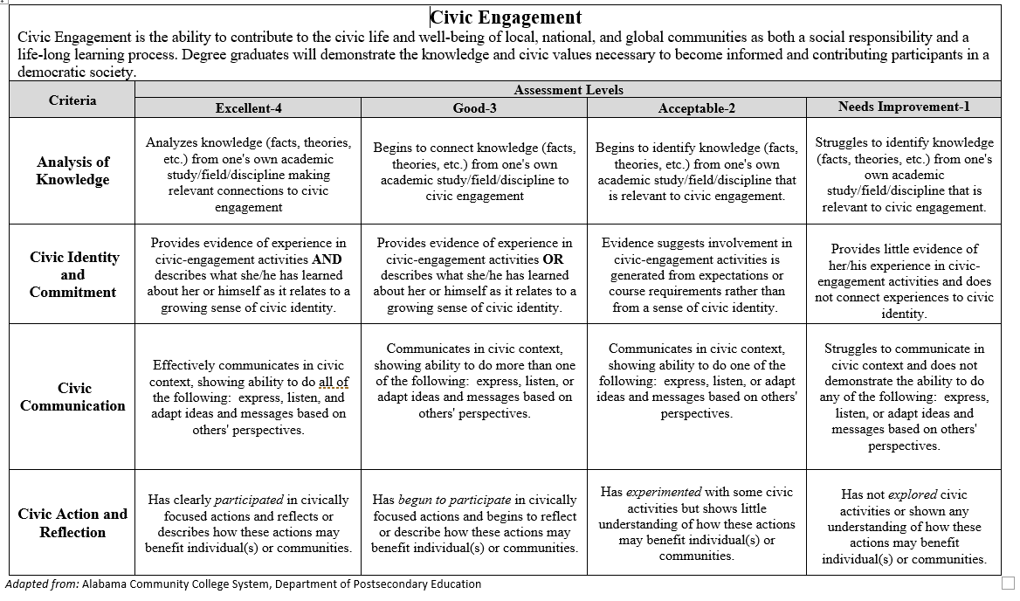

Appendix B – Graduation and Alumni Survey Examples

Image 1. Graduation Survey Civic Engagement Satisfaction Question
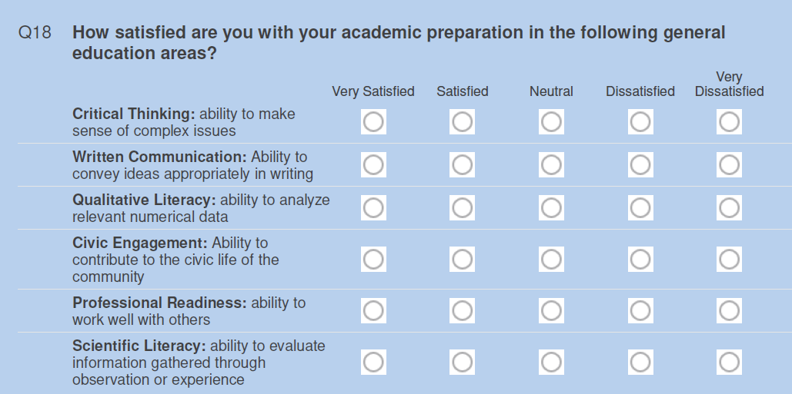

Image 2. Alumni Survey Civic Engagement Satisfaction Question
