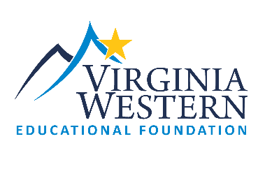
2024-2025
Virginia Western Educational Foundation
Innovation Grant Letter of Intent (LOI)
The LOI must be submitted in order to complete a full application*.
LOI Deadline: November 1, 2023 4:00 pm

Please reply to the following areas to assist the Educational Foundation in understanding your Innovation idea.

Faculty/Staff Member: ________________________________ Email: __________________________________

Project Title: __________________________________________________________________________________

Project purpose and goal(s): Please provide a brief description of the purpose of your request? What are the goals you wish to achieve with your bright idea? (250 word maximum)

Project Outcomes: How will you measure success? (250 word maximum)

Budget: Explain how you will use Innovation Funds? (check anticipated budget categories below). Requests are limited to a maximum of $10,000. (250 word maximum)

Projected Budget Range: Check one of the budget ranges below.

$2,500 or less $2,501-$5,000 $5,001 - $7,500 $7,501 - $10,000

Note the Budget Categories that will be included in your request:
Release Time (requires collaboration with HR) Certifications/Training Conference Attendance

Marketing (limited to 30% of grant total/requires collaboration with Marketing)

Materials/Supplies/Other (please explain) Software/Equipment (requires IET collaboration)

Please describe below any anticipated budget needs noted as “Other”:

*Full applications will require budget and signatures/approvals of immediate supervisor/department head/VP.

Submit completed Letter of Intent to Carolyn Payne at cpayne@virginiawestern.edu
By November 1, 2023 @ 4:00 p.m.
Please note, late applications will not be accepted.

